The manual for “Macro_for_DAPI_and_X-Gal_counting_Version_1_Single.ijm”

Notes: images of senescence-associated beta-galactosidase (X-Gal) and DAPI staining should be acquired with the same 10x objective and the same color camera.
The contrast from X-Gal images should originate from X-Gal color alone; any other contrast (phase contrast or similar) should be avoided.
The macro supports RGB image type with single slice and 8 or 12 (16)-bit image types with 3 slices (color camera channels).
Activate the Windowless import in Plugins – Bio-Formats, set it to Hyperstack with Default color mode and run the macro.

The macro will guide you through the analysis and print the result at the end.

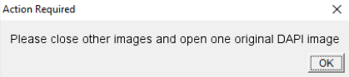
Please open one original DAPI image when prompted; click OK when you finish.

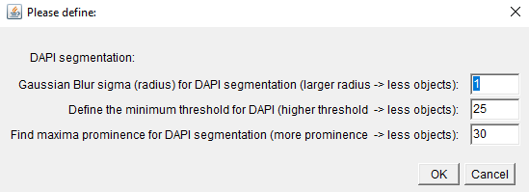
Define the Gaussian Blur radius, minimum threshold and Find Maxima prominence for DAPI segmentation.

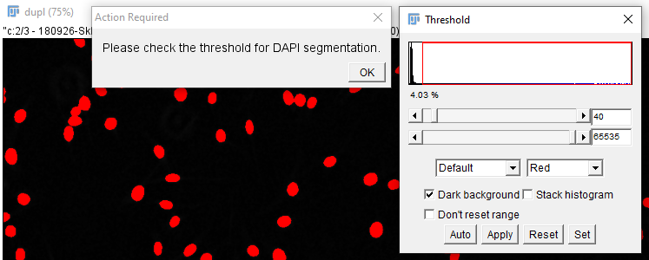
Please check the minimum threshold for DAPI segmentation and click OK.

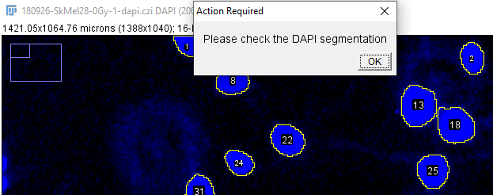
Check the DAPI segmentation. If too many nuclei appear connected reduce the Gaussian Blur radius and/or reduce Find Maxima prominence in the next round.


If you are satisfied, click Yes and continue with X-Gal segmentation.

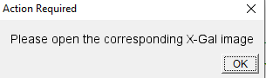
Open the indicated X-Gal image and click OK.

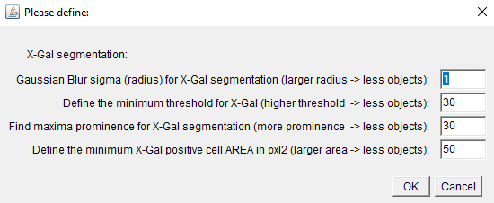
Define the Gaussian Blur radius, minimum threshold, Find Maxima prominence and minimum cell area (pxl2) for X-Gal segmentation.

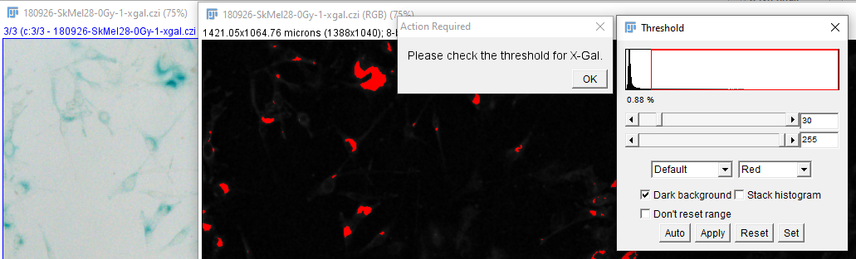
Please define the minimum threshold for X-Gal segmentation; if necessary compare it to the original image and click OK when you finish.


Loop back if not satisfied.
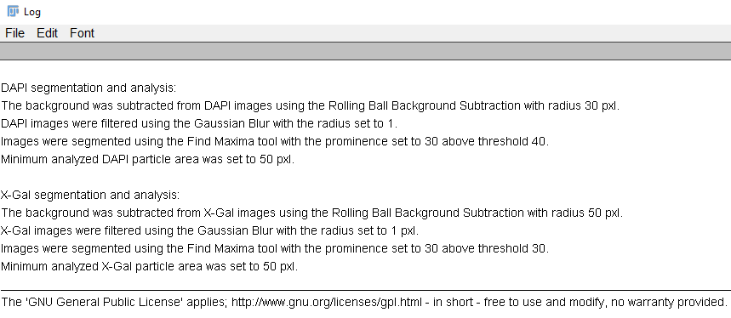
The Log file will be printed at the end; copy it and use it later to define settings for Batch analysis.

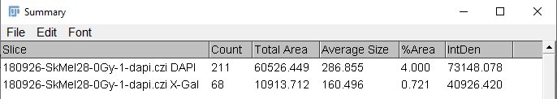

The summary window contains total (DAPI) and X-Gal positive cell count. Area, Size and other measurements can be ignored

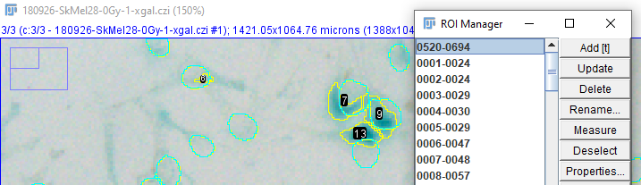
Inspect the result visually with ROI Manager. The first ROI will be automatically selected demarcating DAPI. The other ROIs represent X-Gal positive cells.

